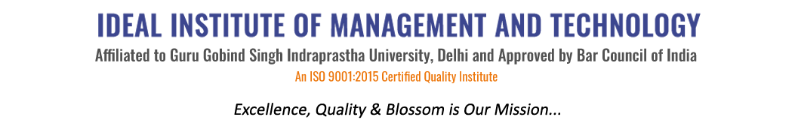
16 X, Karkardooma Institutional Area, (Near Telephone Exchange)
Delhi-110092
+91 (11) 22372639, 22375961,
http://idealinstitute.edu.in
INDUSTRIAL VISIT TO AMAR UJALA PUBLICATION LTD. - 14TH MARCH 2016

S. No. | Name | Enroll No.
1 | ABHAY SAHLOT | 00121001715
2 | ALISHA TYAGI | 00321001715
3 | JIGYASU PANT | 00721001715
4 | KANIKA VERMA | 00921001715
5 | KOMAL BOTHRA | 01121001715
6 | KUNAL AGGARWAL | 01321001715
7 | LAKSHAY KHANNA | 01421001715
8 | MANDEEP KAUR | 01521001715
9 | MIIT VAID | 01621001715
10 | MONIKA NEGI | 01821001715
11 | NISHANT ARORA | 02121001715
12 | NISHTHA SHARMA | 02221001715
13 | PRIYANKA KUMARI | 02321001715
14 | RAHUL ARORA | 02421001715
15 | SAMARTH GANDOTRA | 02821001715
16 | SHUBHAM | 03121001715
17 | SONIA | 03221001715
18 | SUBI GOENKA | 03421001715
19 | VARUN CHOPRA | 03621001715
20 | KOMAL SHARMA | 40121001715
21 | PALAK GANDHI | 40221001715
22 | SRISHTI AGGARWAL | 40421001715
23 | SAUMYA VERMA | 40721001715
24 | RAJAT JAIN | 40821001715
25 | DEEPANSHU SHARMA | 40921001715
26 | RIYA NARULA | 41021001715
27 | SHIVAM SHARMA | 41121001715
28 | ASHISH MALIK | 41421001715
29 | SHIKHAR BHARDWAJ
30 | MANSI SAINI
31 | VASU RASTOGI

